**Do the below codelabs to exercise your ondevice ML skills and in github provide all the artifacts and screenshots of your work (do not copy from codelab the screenshot.**

1. **Mobile App and Image training on device: Build and deploy a custom object detection model using tflite on android simulator (**[**https://developers.google.com/codelabs/tflite-object-detection-android?hl=en#0 (Links to an external site.)**](https://developers.google.com/codelabs/tflite-object-detection-android?hl=en#0)**)**

## ****Prerequisites****

This codelab has been designed for experienced mobile developers who want to gain experience with Machine Learning. You should be familiar with:

* Android development using Kotlin and Android Studio
* Basic Python syntax

## ****What you'll learn****

* How to train a custom object detection model using TFLite Model Maker.
* How to deploy a TFLite object detection model using TFLite Task Library.

## What you'll need

* A recent version of Android Studio (v4.2+)
* Android Studio Emulator or a physical Android device
* [The sample code](https://github.com/googlecodelabs/odml-pathways/archive/refs/heads/main.zip)
* Basic knowledge of Android development in Kotlin

## [3. Get set up](https://developers.google.com/codelabs/tflite-object-detection-android?hl=en#2)

Unpack the downloaded zip file. This will unpack a root folder (odml-pathways-main) with all of the resources you will need. For this codelab, you will only need the sources in the object-detection/codelab2/android subdirectory.

The android subdirectory in the object-detection/codelab2/android repository contains two directories:

* **starter**—Starting code that you build upon for this codelab.
* **final**—Completed code for the finished sample app.

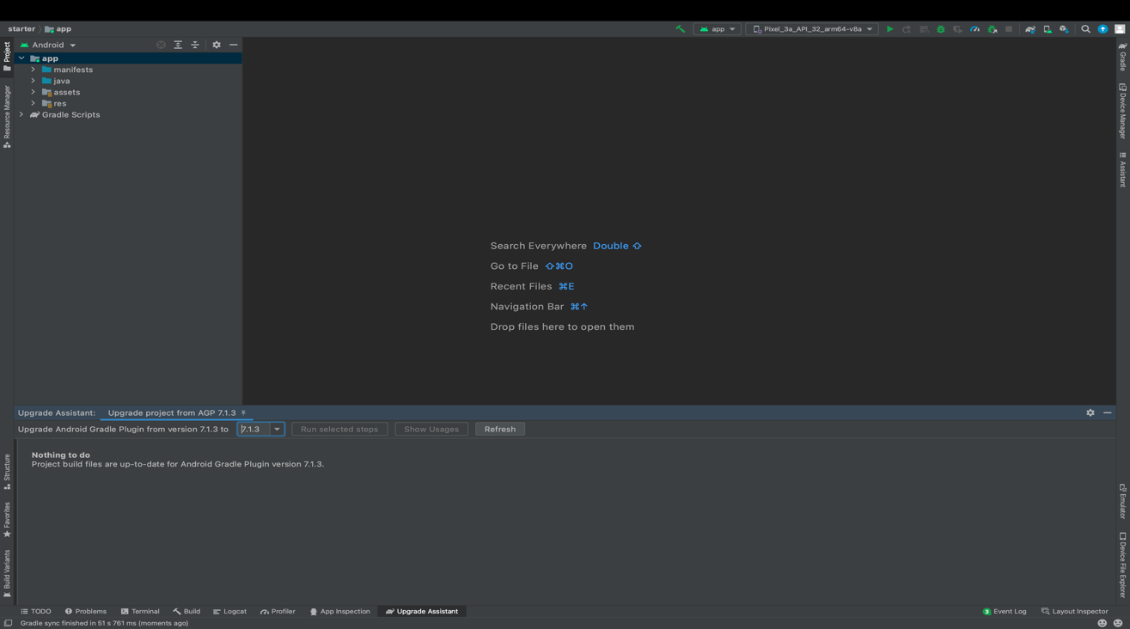

## [4. Understand the starter app](https://developers.google.com/codelabs/tflite-object-detection-android?hl=en#3)

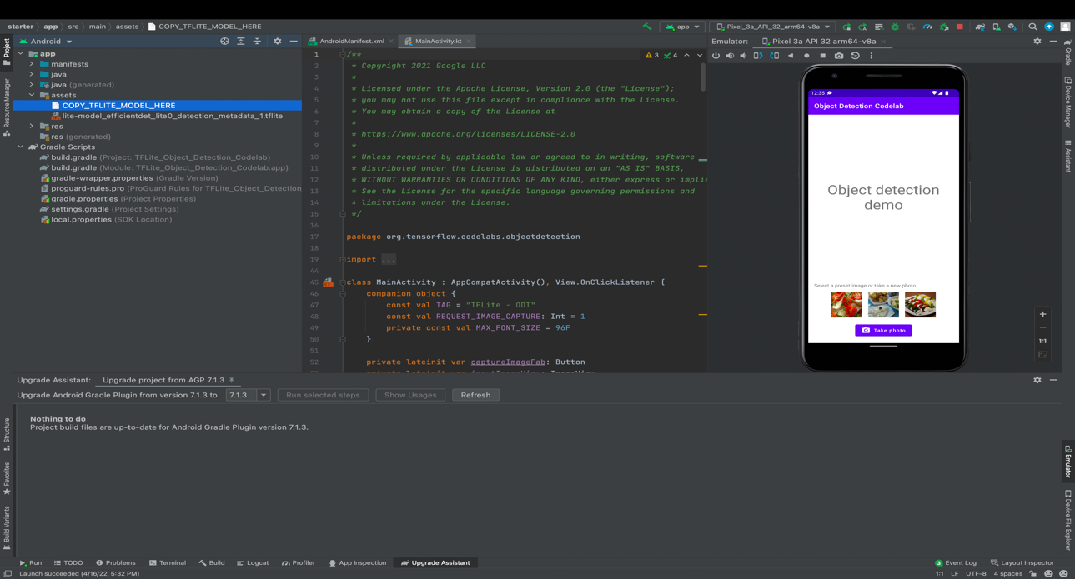

## [5. Add on-device object detection](https://developers.google.com/codelabs/tflite-object-detection-android?hl=en#4)

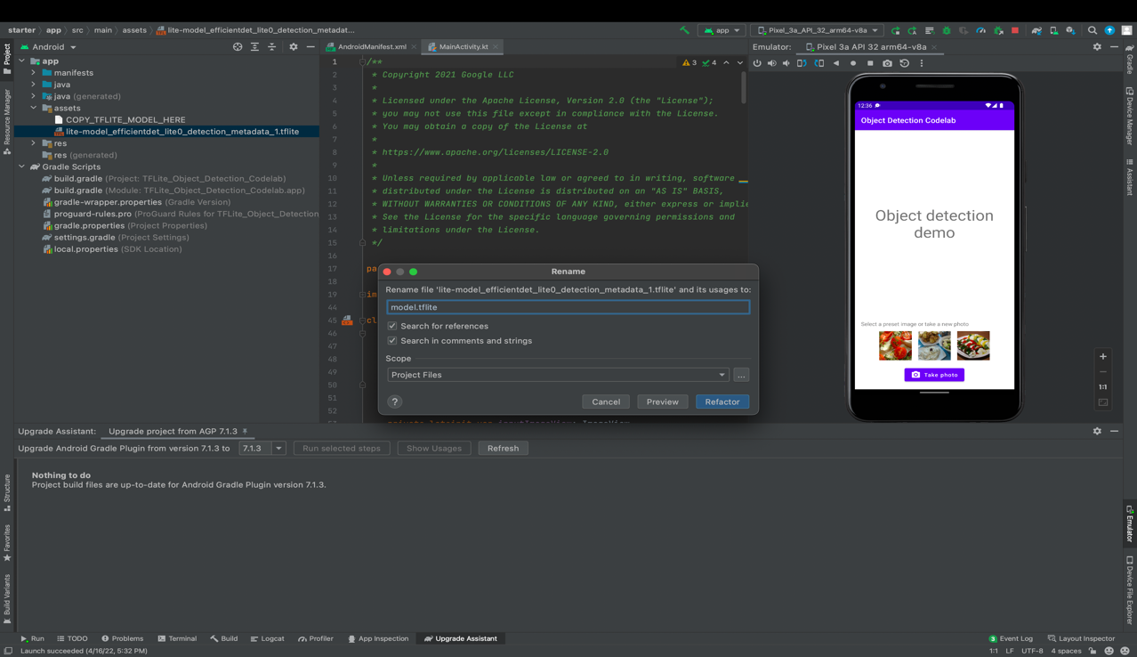

**Update the Gradle file Task Library dependencies**

Go to the app/build.gradle file and add this line into the dependencies configuration:

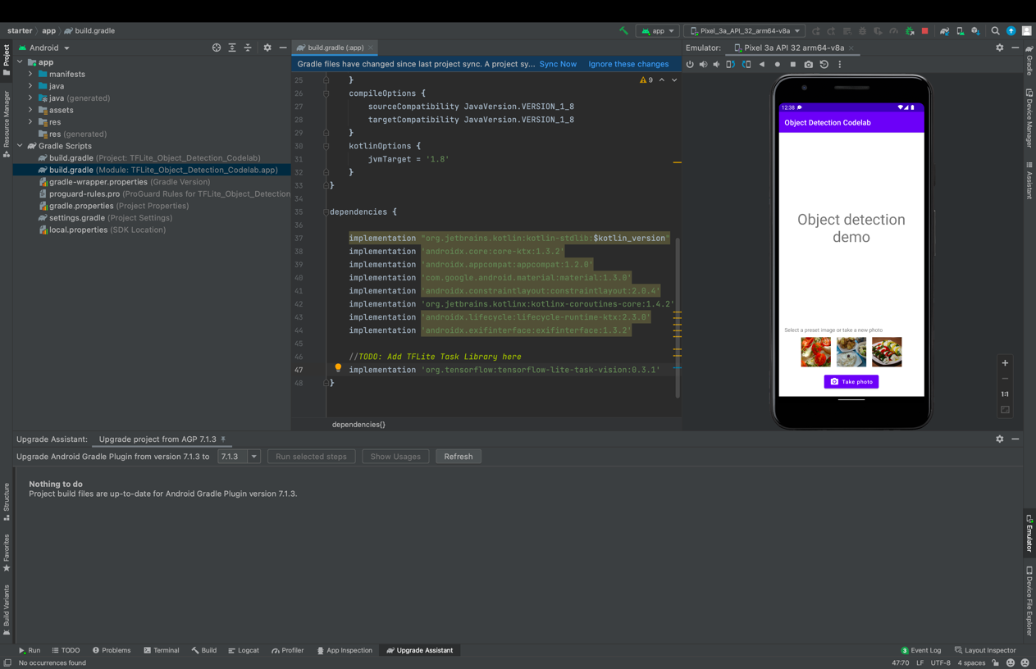

## ****Sync your project with gradle files****

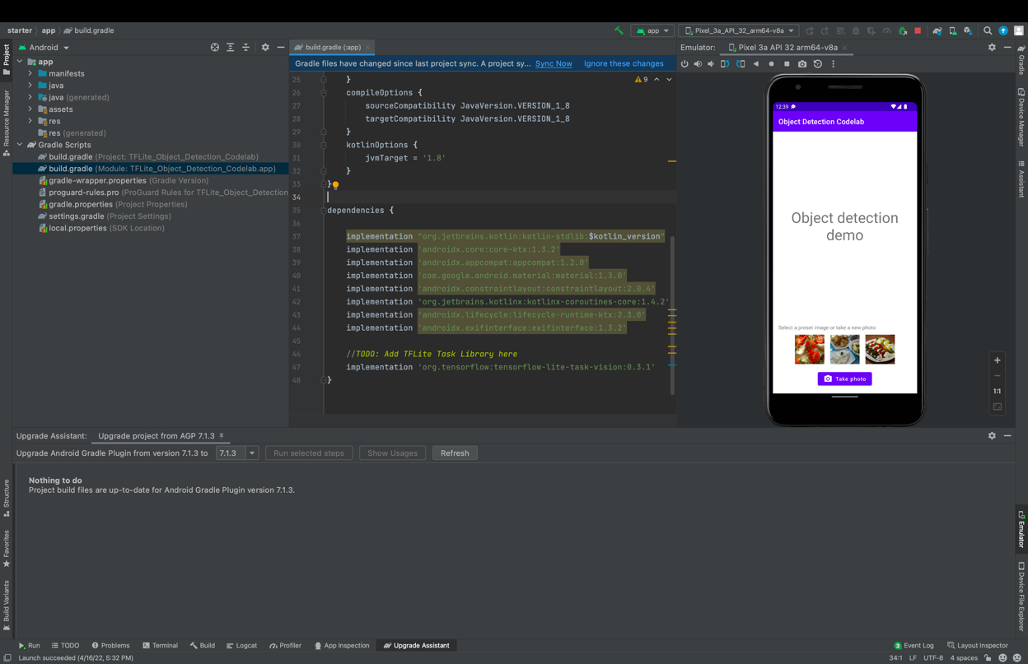



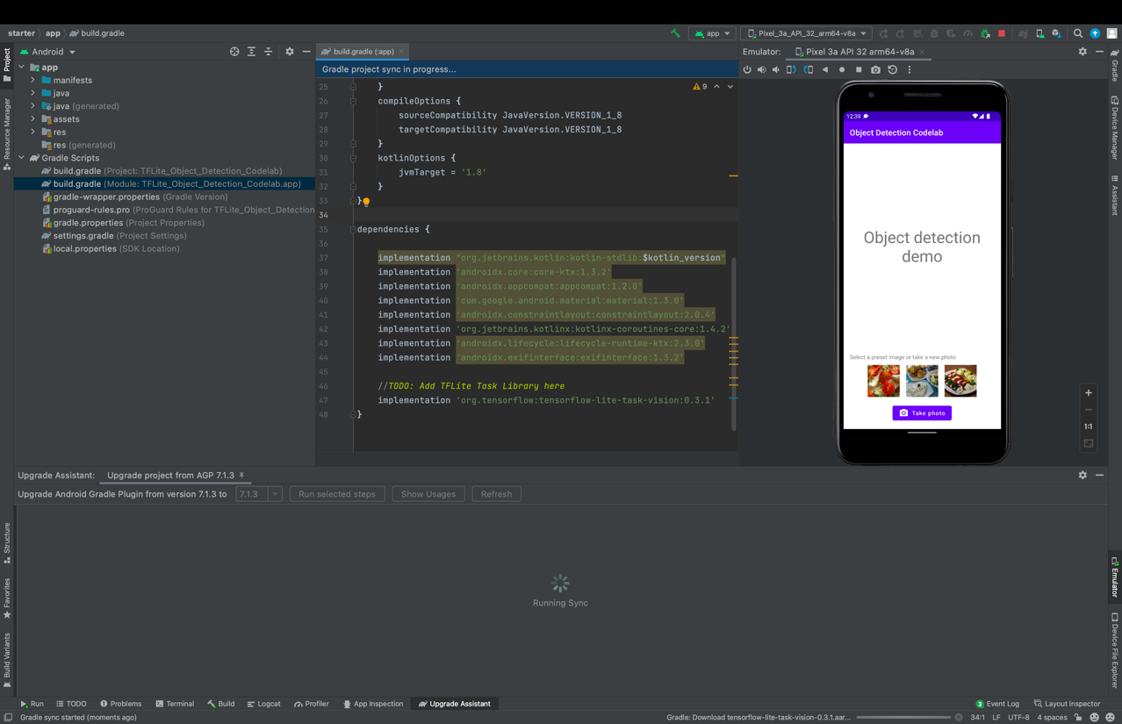

## **Follow below steps :-**

## **Create Image Object**

## **Create a Detector instance**

## **Feed Image(s) to the detector**

## **Print the detection results**

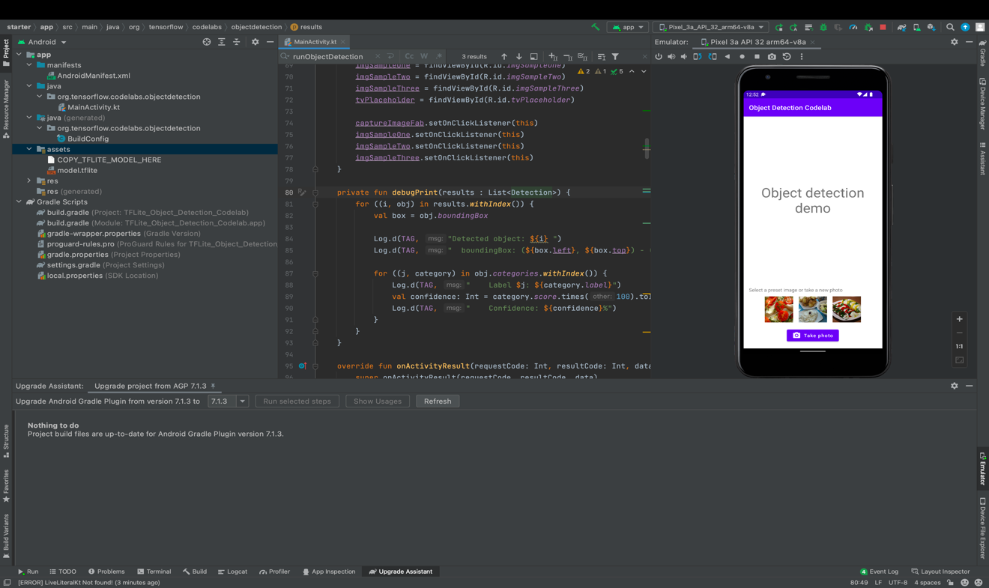

Run the model –

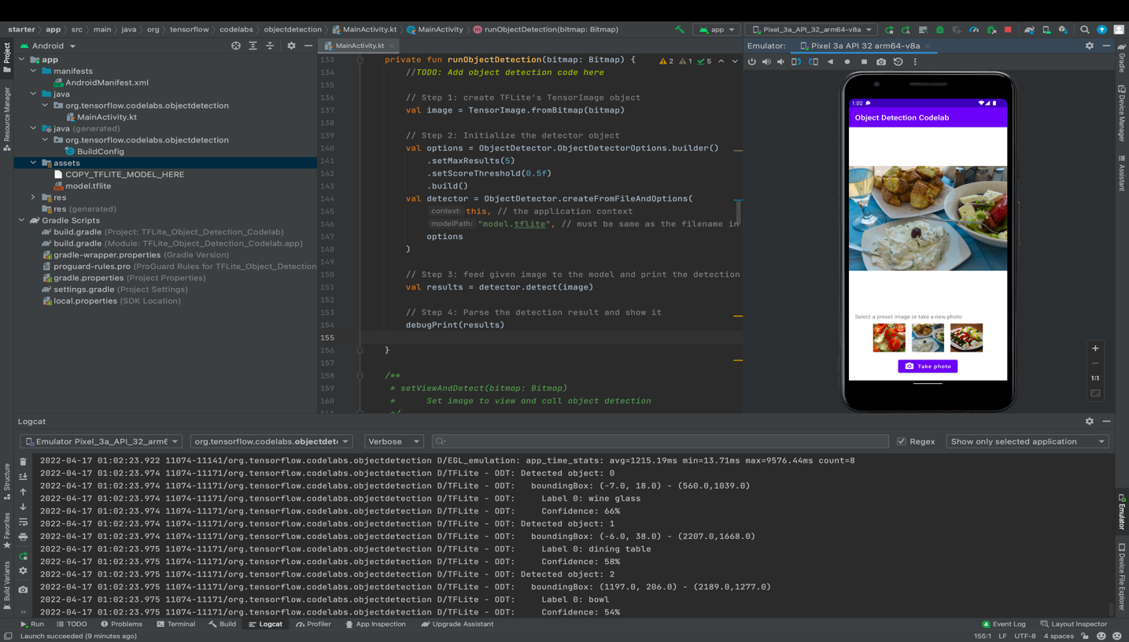

## [6. Draw the detection result on the input image](https://developers.google.com/codelabs/tflite-object-detection-android?hl=en#5)

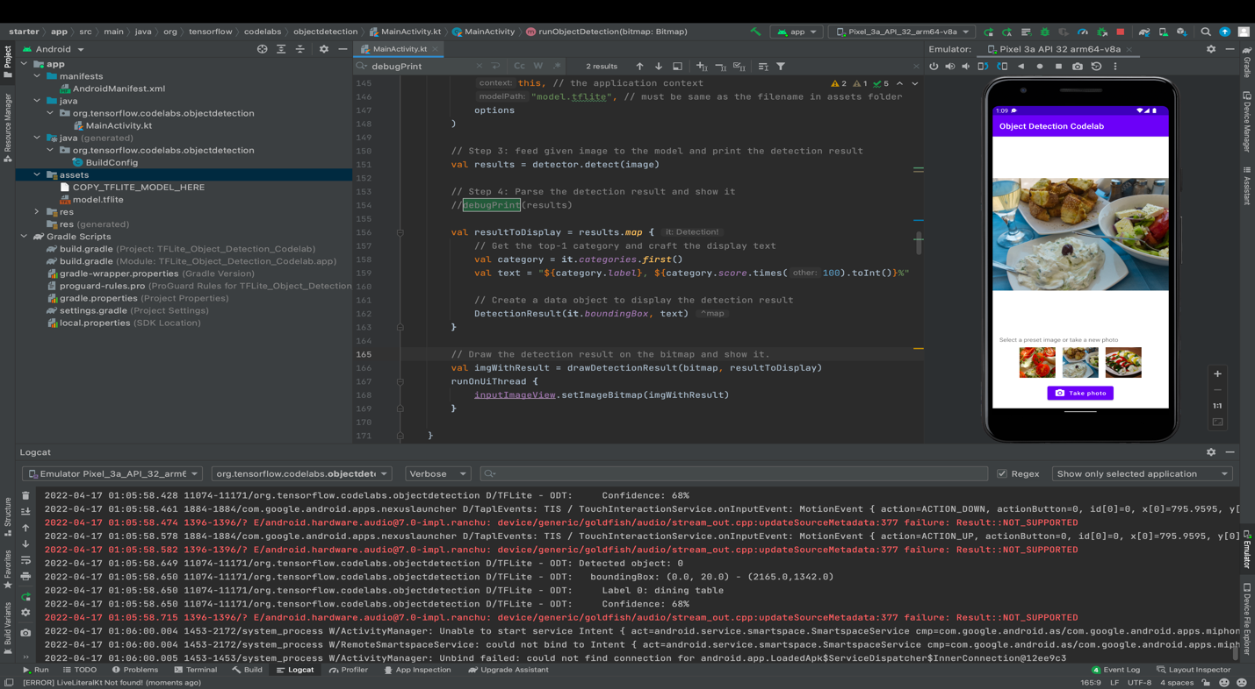

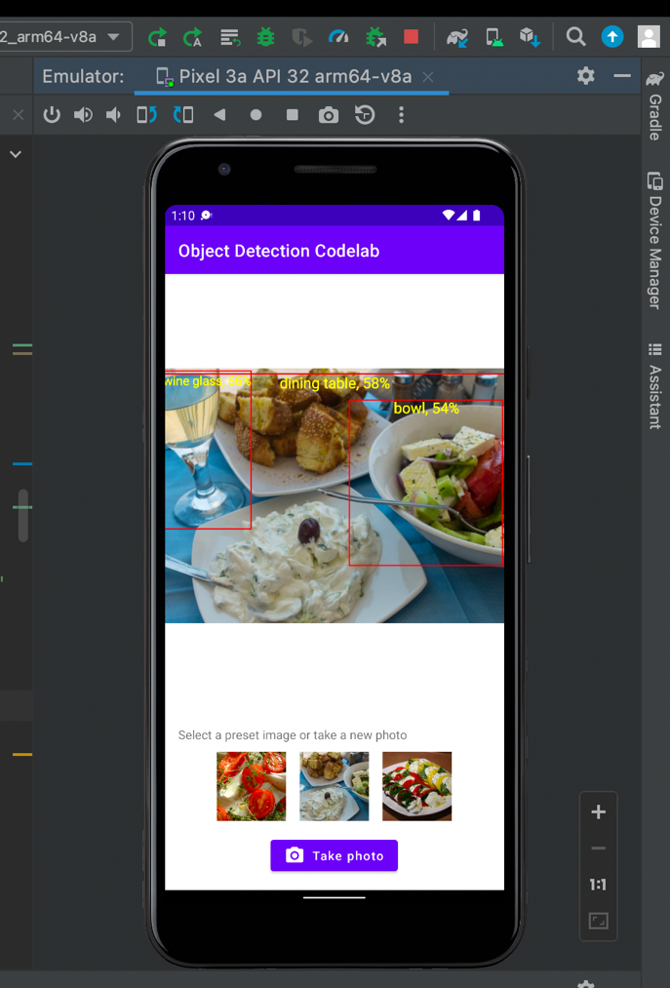

## [7. Train a custom object detection model](https://developers.google.com/codelabs/tflite-object-detection-android?hl=en#6)

Here is a [dataset](http://storage.googleapis.com/cloud-ml-data/img/openimage/csv/salads_ml_use.csv) containing images and labels that you can use to practice training your own custom model. It was created using images from the [Open Images Dataset V4](https://storage.googleapis.com/openimages/web/index.html).

Here is the link to the colab - <https://github.com/NishaMDev/DeepLearning/blob/main/Assignment%235/PART_B_a)_Train_a_salad_detector_with_TFLite_Model_Maker.ipynb>

## [8. Integrate the custom TFLite model to the Android app](https://developers.google.com/codelabs/tflite-object-detection-android?hl=en#7)

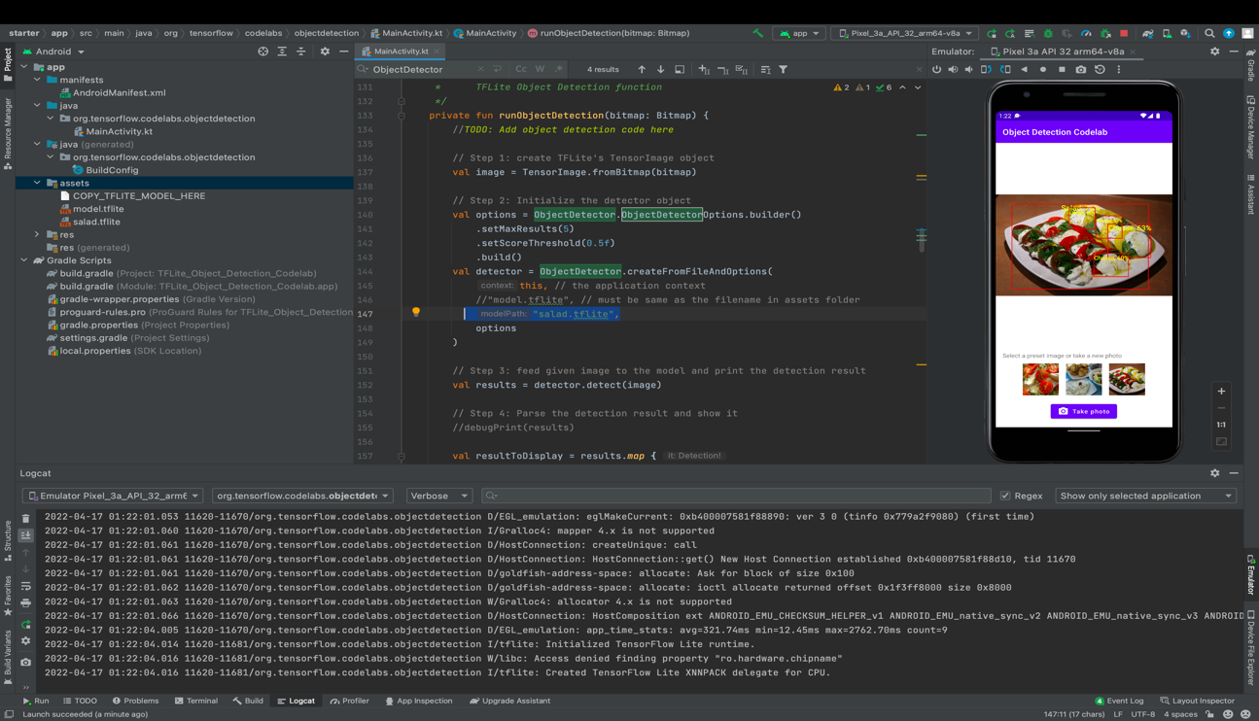

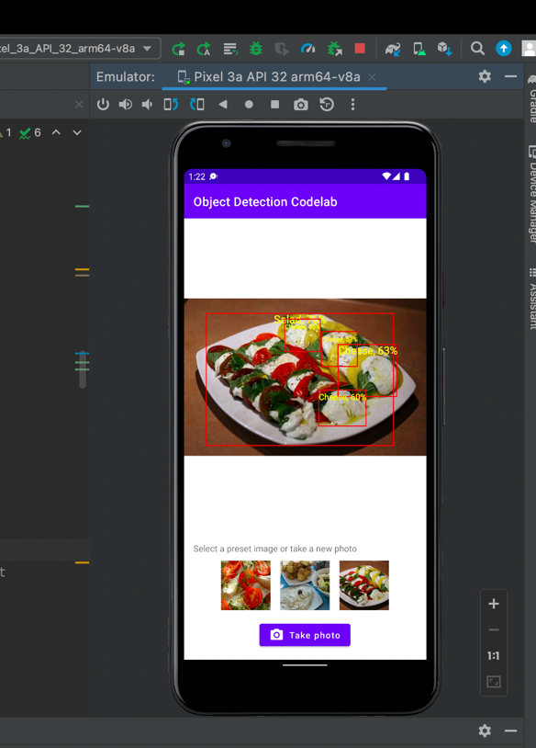

1. Mobile app and audio training on device : Build a custom pre-trained Audio Classification model ([https://developers.google.com/codelabs/tflite-audio-classification-custom-model-android?hl=en#0 (Links to an external site.)](https://developers.google.com/codelabs/tflite-audio-classification-custom-model-android?hl=en#0))

## [The Birds dataset](https://developers.google.com/codelabs/tflite-audio-classification-custom-model-android?hl=en#1)

You will use a Birdsong dataset that is already prepared to make it easier to use. All the audio files come from the [Xeno-canto website](https://www.xeno-canto.org/" \t "_blank).

## [3. Get the sample code](https://developers.google.com/codelabs/tflite-audio-classification-custom-model-android?hl=en#2)

**Import the starter app**

Start by importing the starter app into Android Studio:

1. Open Android Studio and select Import Project (Gradle, Eclipse ADT, etc.)
2. Open the starter folder (audio\_classification/codelab2/android/starter) from the source code you downloaded earlier.

## [5. Train a custom Audio Classification model with Model Maker](https://developers.google.com/codelabs/tflite-audio-classification-custom-model-android?hl=en#4)

## Github Link –

## <https://github.com/NishaMDev/DeepLearning/blob/main/Assignment%235/PART_B_b)_Model_maker_audio_colab.ipynb>

## [6. Add the custom TFLite model to the Android app](https://developers.google.com/codelabs/tflite-audio-classification-custom-model-android?hl=en#5)

## [7. Load the new model on the base app](https://developers.google.com/codelabs/tflite-audio-classification-custom-model-android?hl=en#6)

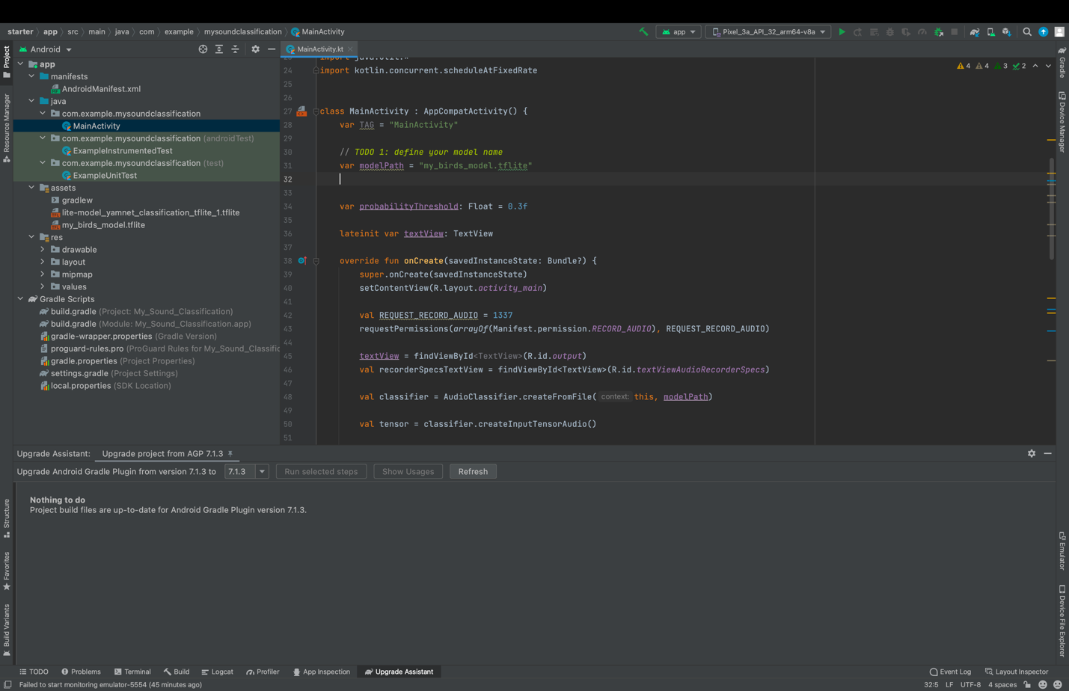

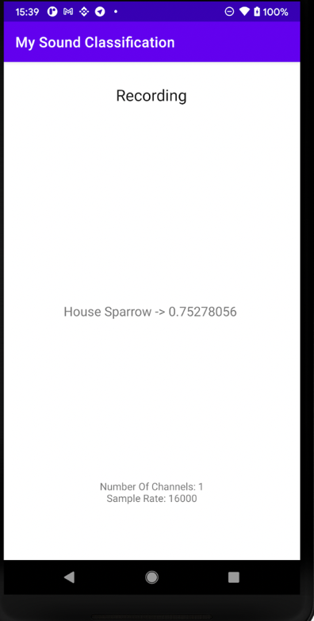

1. Web app and image training on device: TensorFlow.js Transfer Learning Image Classifier (<https://codelabs.developers.google.com/codelabs/tensorflowjs-teachablemachine-codelab?hl=en#0 (Links to an external site. )>)

Live Site Link - <https://available-rapid-vessel.glitch.me>

Code - <https://glitch.com/edit/#!/available-rapid-vessel>

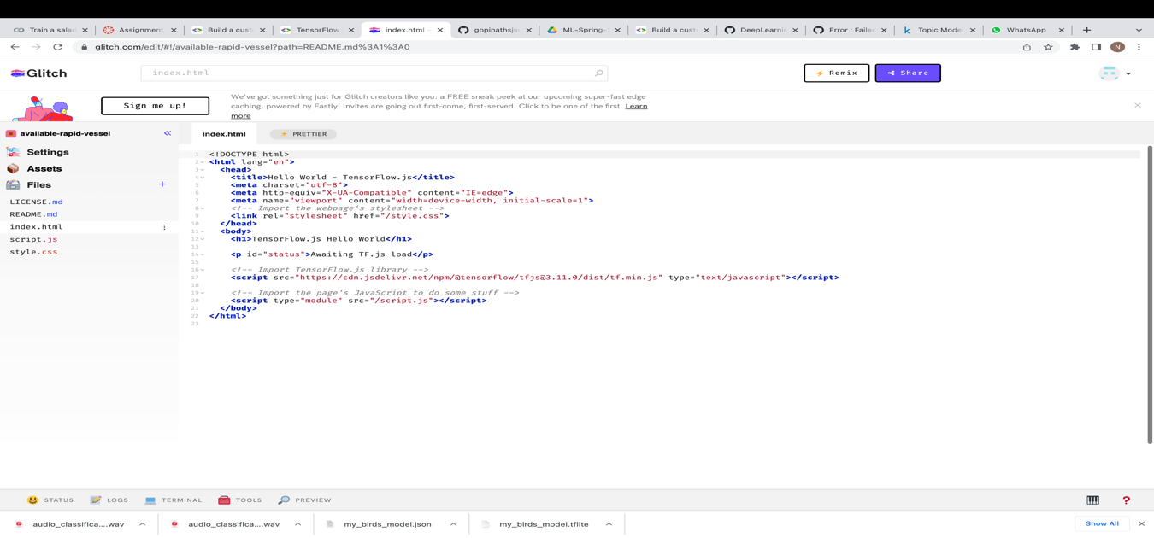

Copy index.html

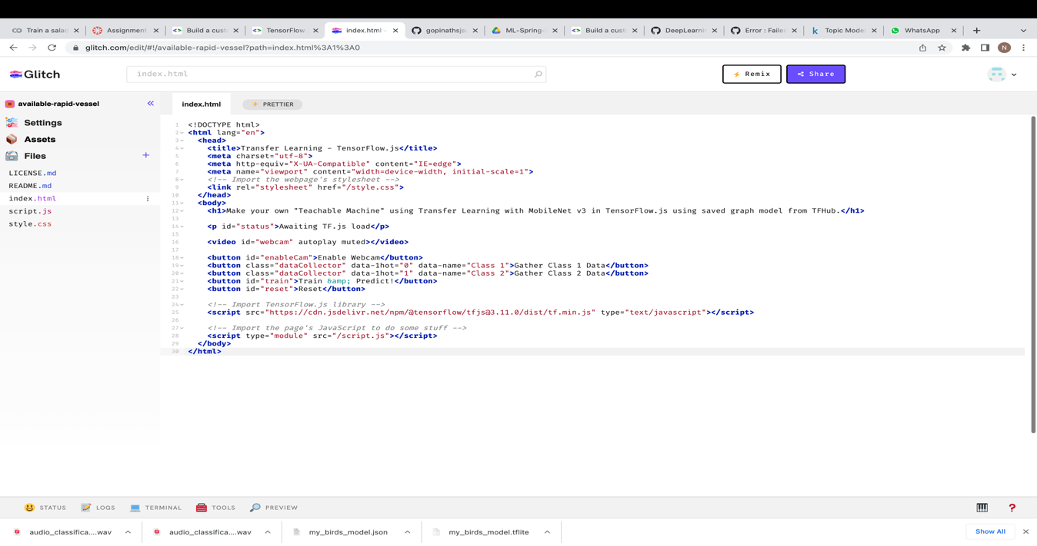

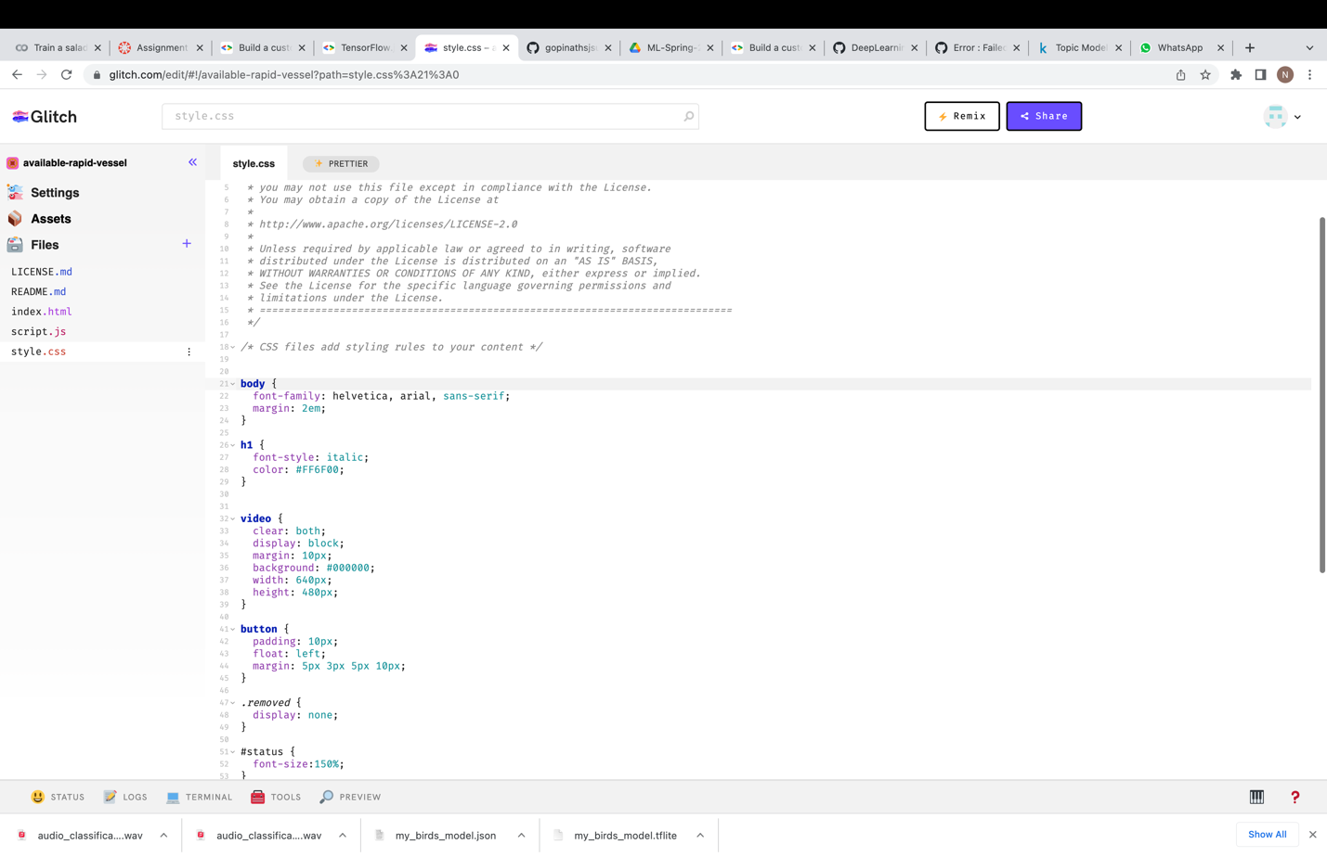

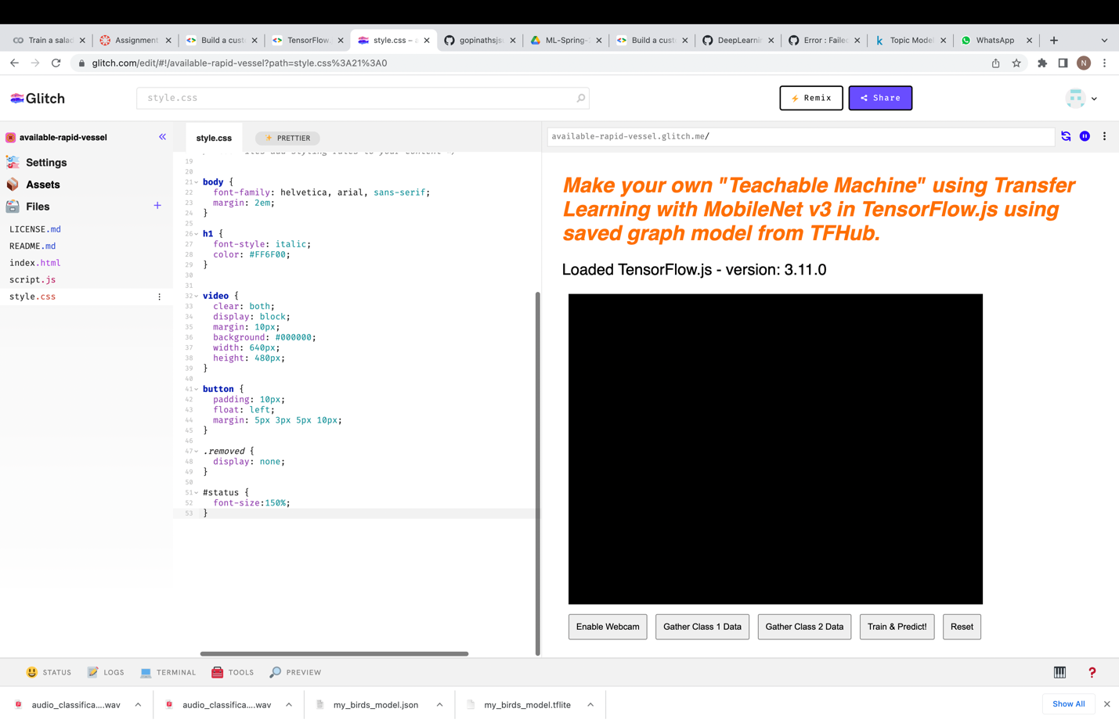

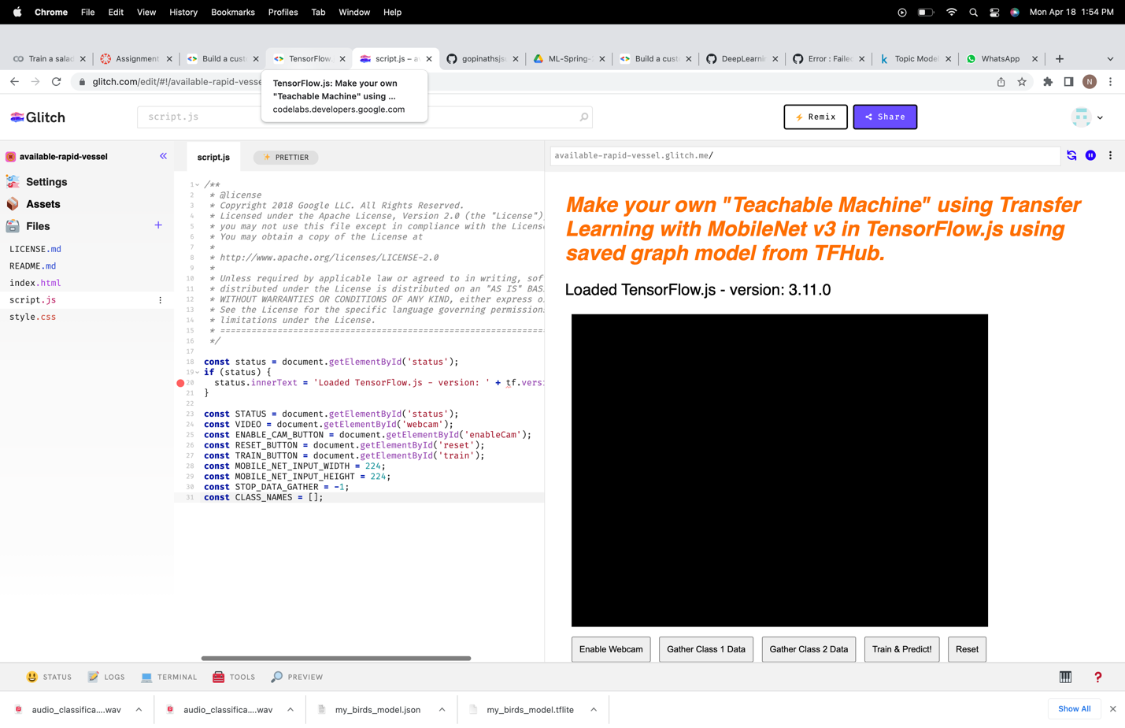

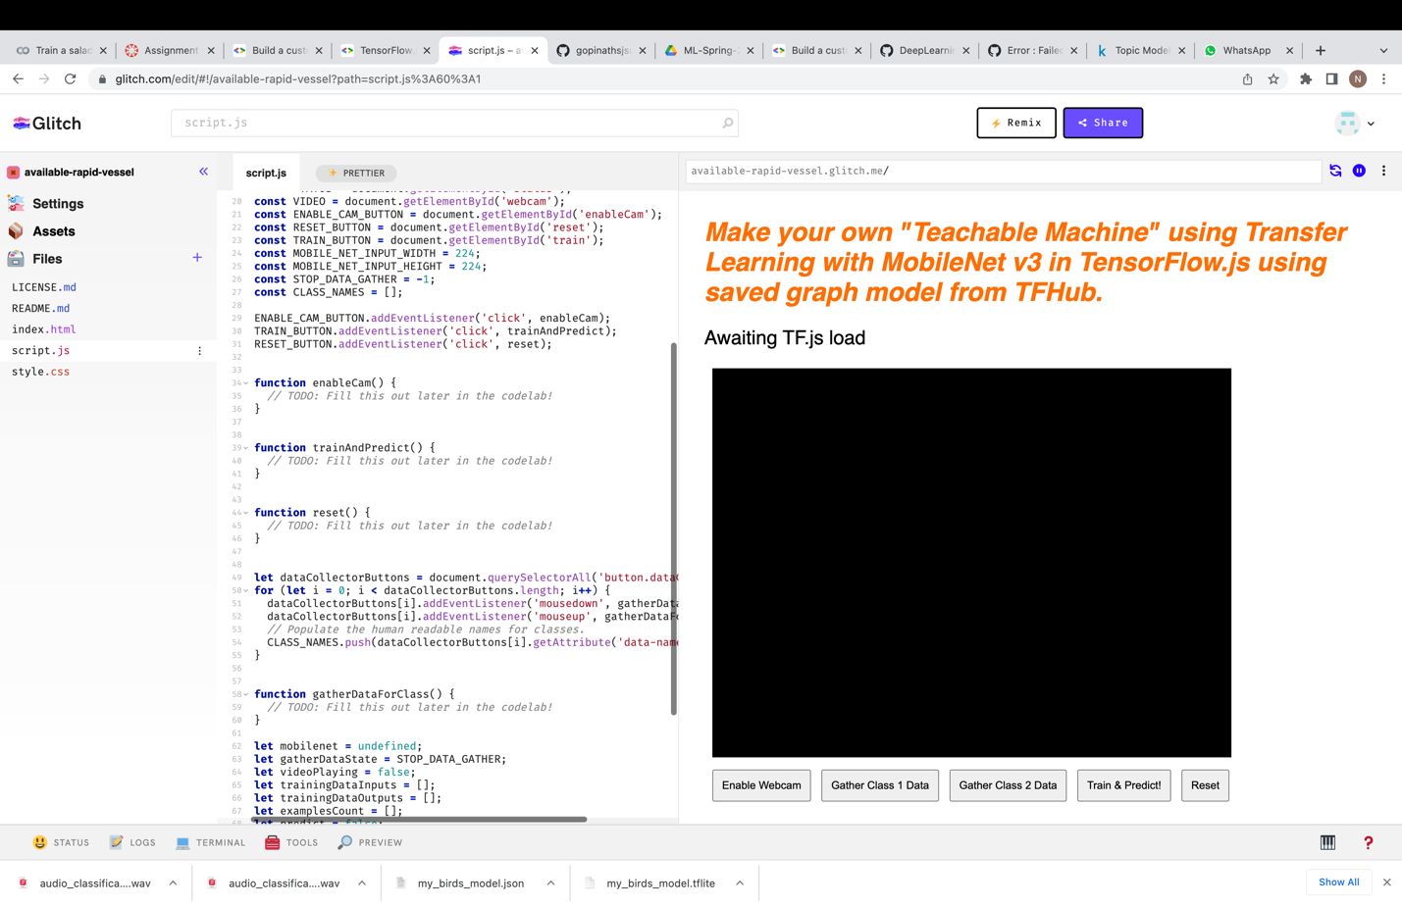

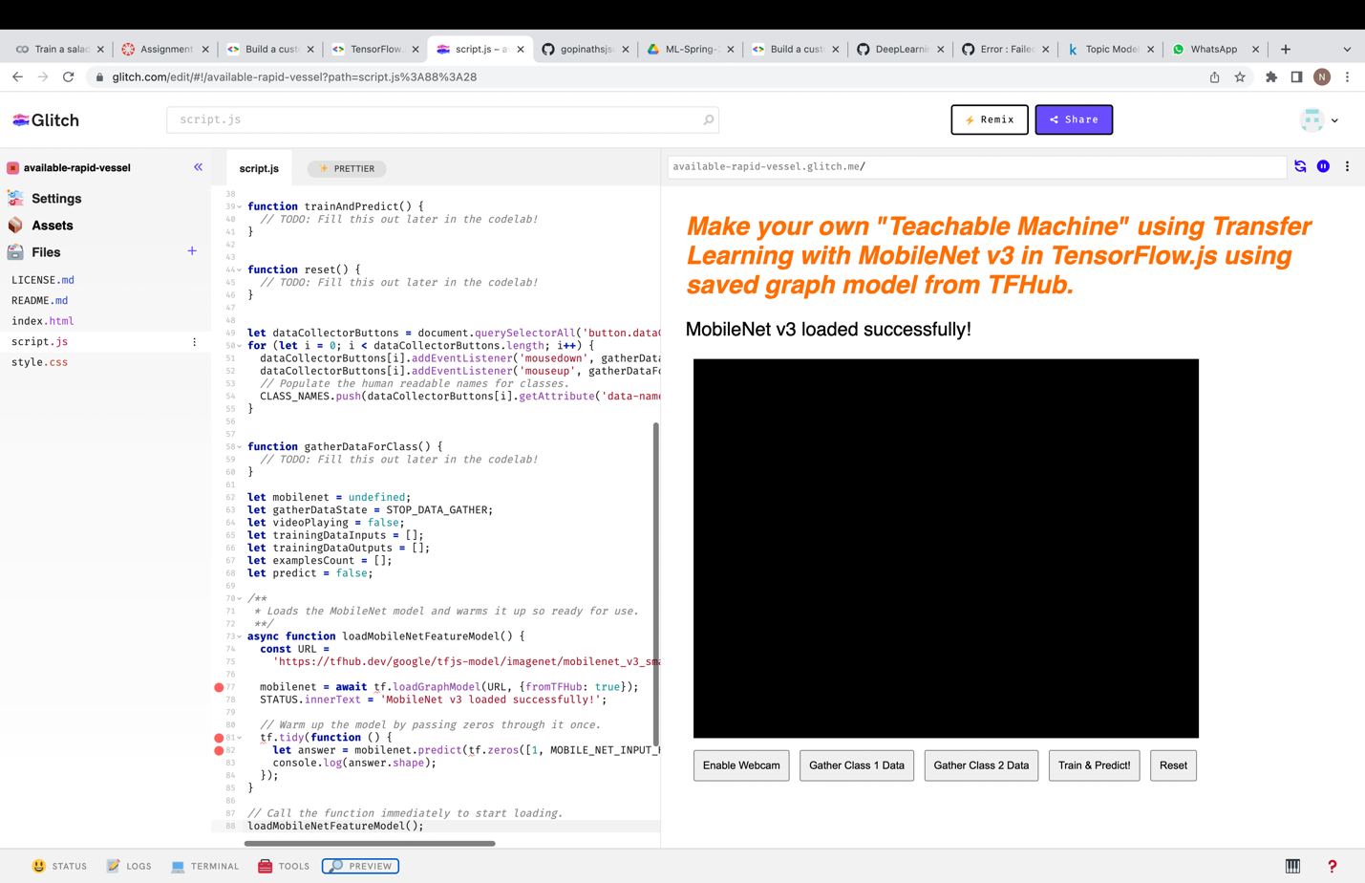

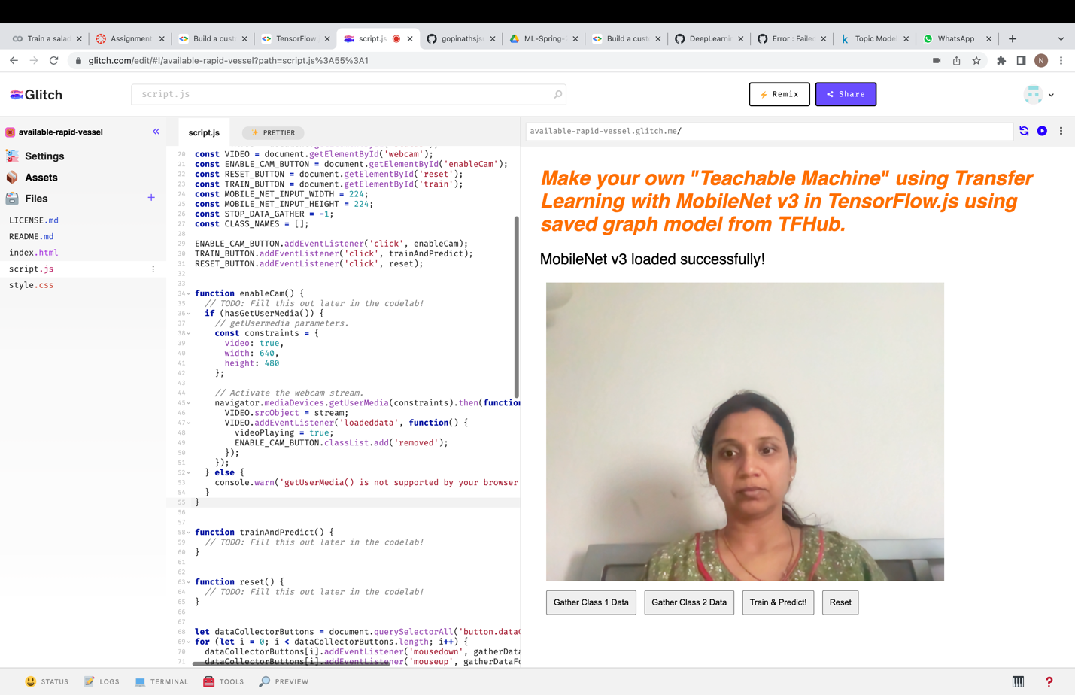

Video –

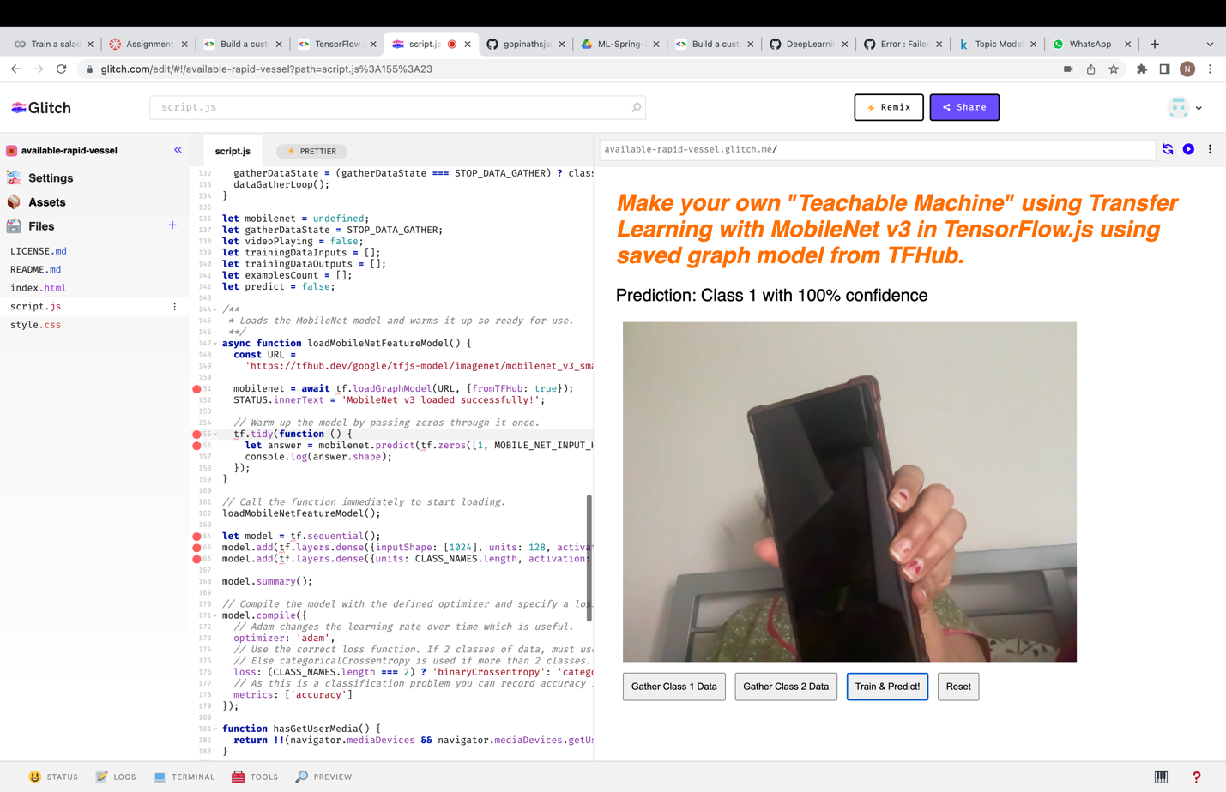

1. Webapp and audio training on device : TensorFlow.js - Audio recognition using transfer learning ([https://codelabs.developers.google.com/codelabs/tensorflowjs-audio-codelab?hl=en#0 (Links to an external site.)](https://codelabs.developers.google.com/codelabs/tensorflowjs-audio-codelab?hl=en#0))

Live Site Link - <https://adaptable-picturesque-stretch.glitch.me>

Code - <https://glitch.com/edit/#!/adaptable-picturesque-stretch>

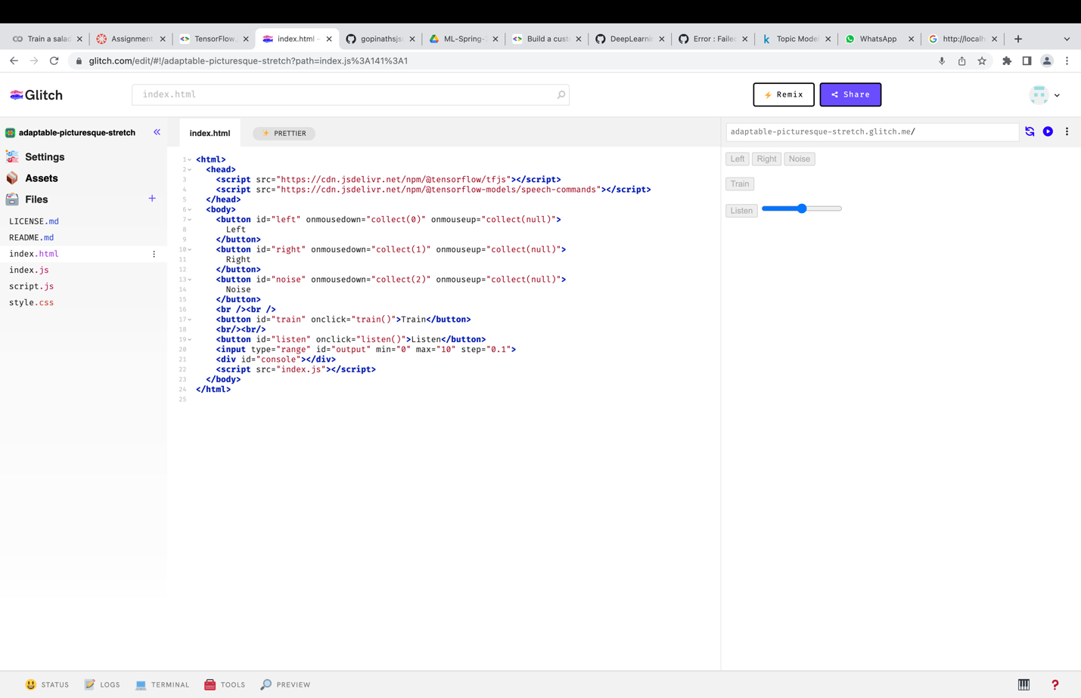

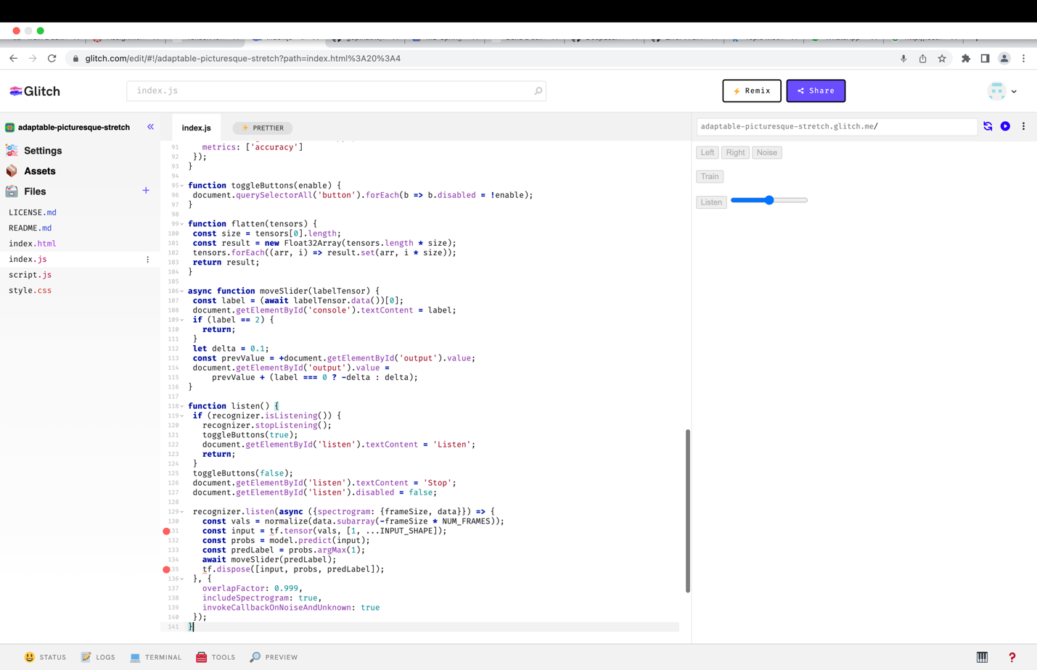

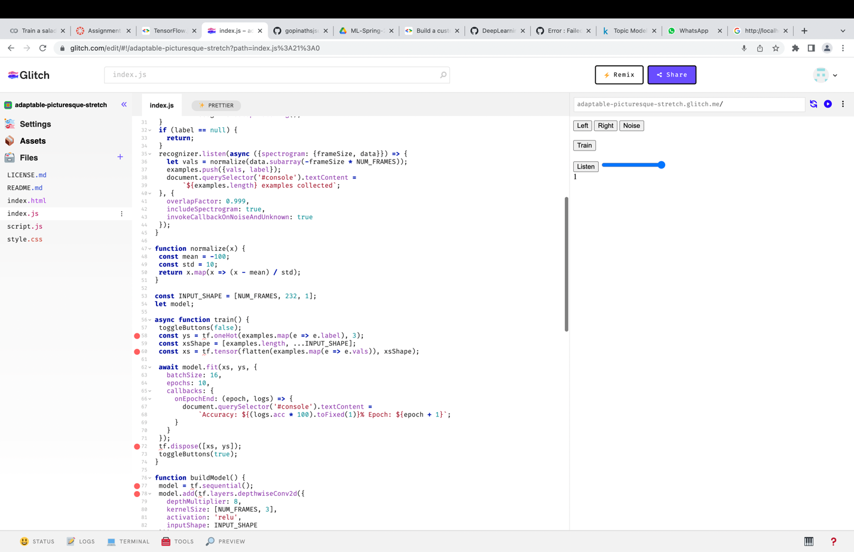

1. Using out of box sdk to do ML ondevice : Use ML Kit to perform [Recognize text and facial features with ML Kit: Android (Links to an external site.)](https://codelabs.developers.google.com/codelabs/mlkit-android?hl=en), and [Recognize, Identify Language and Translate text with ML Kit and CameraX: Android](https://codelabs.developers.google.com/codelabs/mlkit-android-translate?hl=en)

***Recognize text and facial features with ML Kit: Android***

***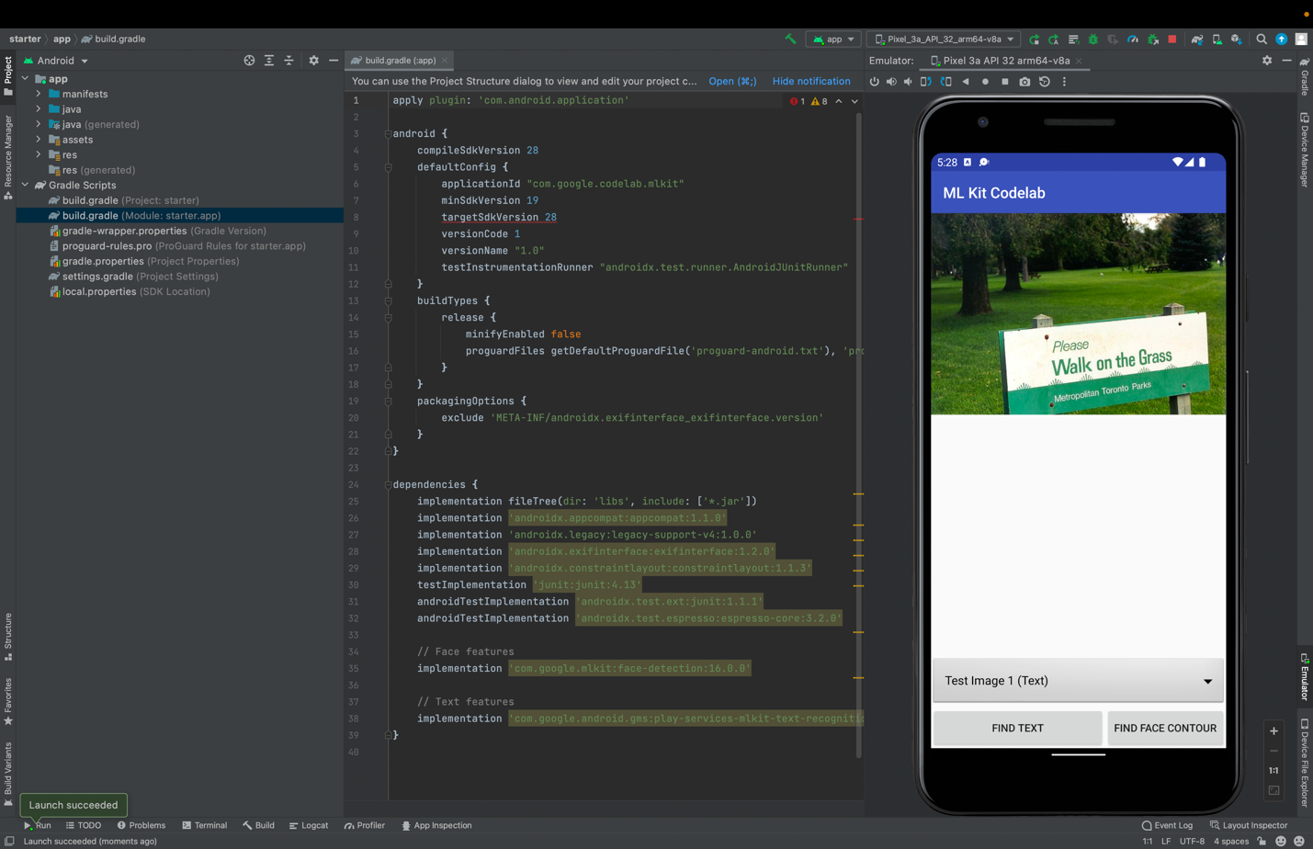***

Paired the Android Studio with Android Phone and tested the code, below are the screenshots:-

***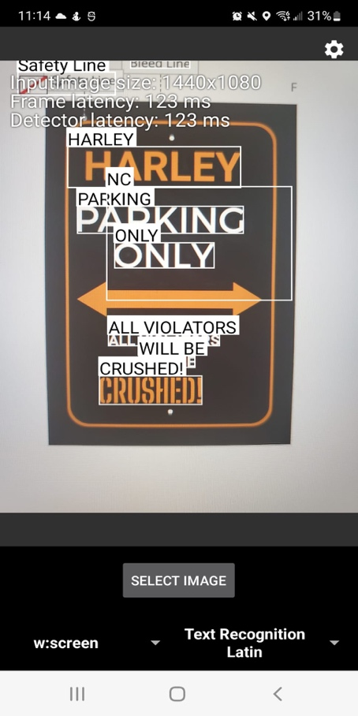 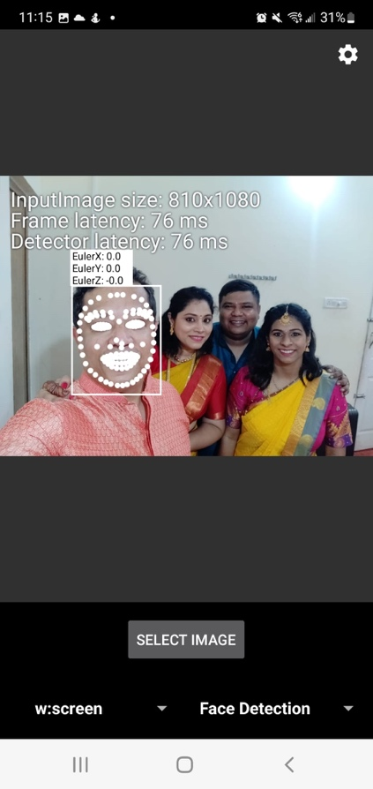 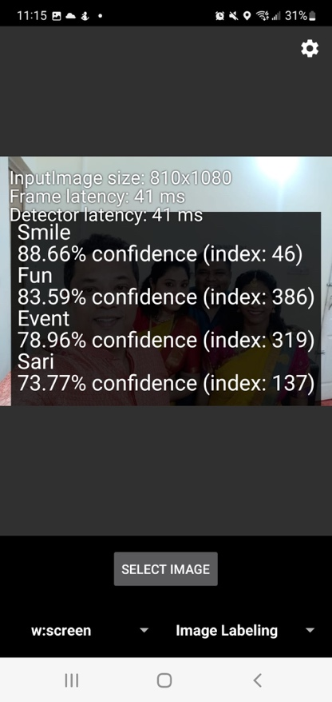***

***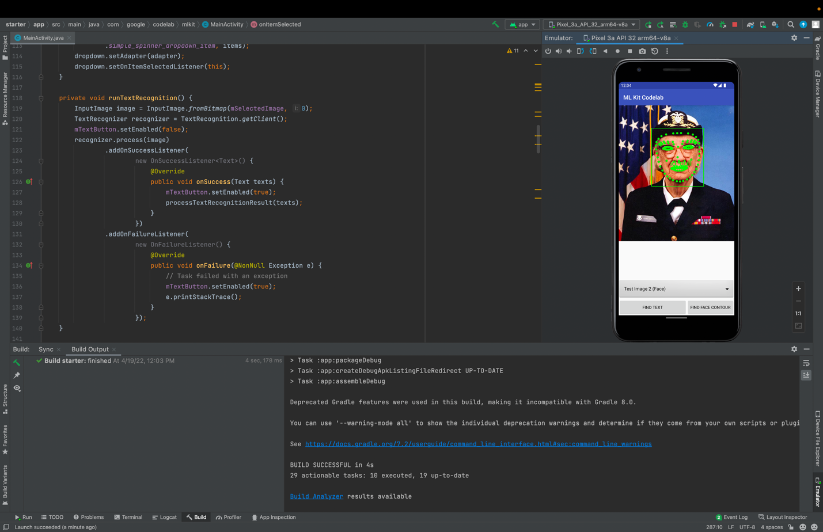***

[***Recognize, Identify Language and Translate text with ML Kit and CameraX: Android***](https://codelabs.developers.google.com/codelabs/mlkit-android-translate?hl=en)***:-***

***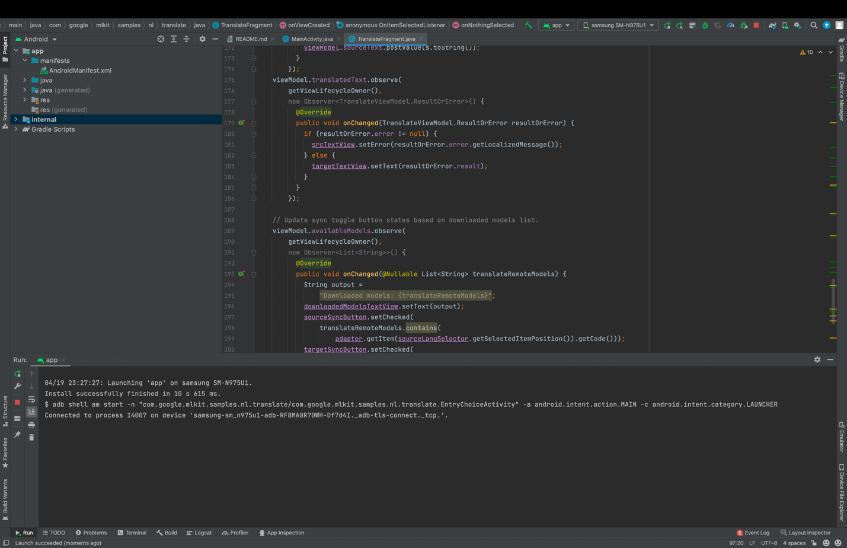***



Connected to Samsung Android smart phone via Wifi Debugging in Developer Options.

**Translation from English to Telegu, Hindi, Urdu and Marathi :-**

